# Build an EMA-based Signal Strategy

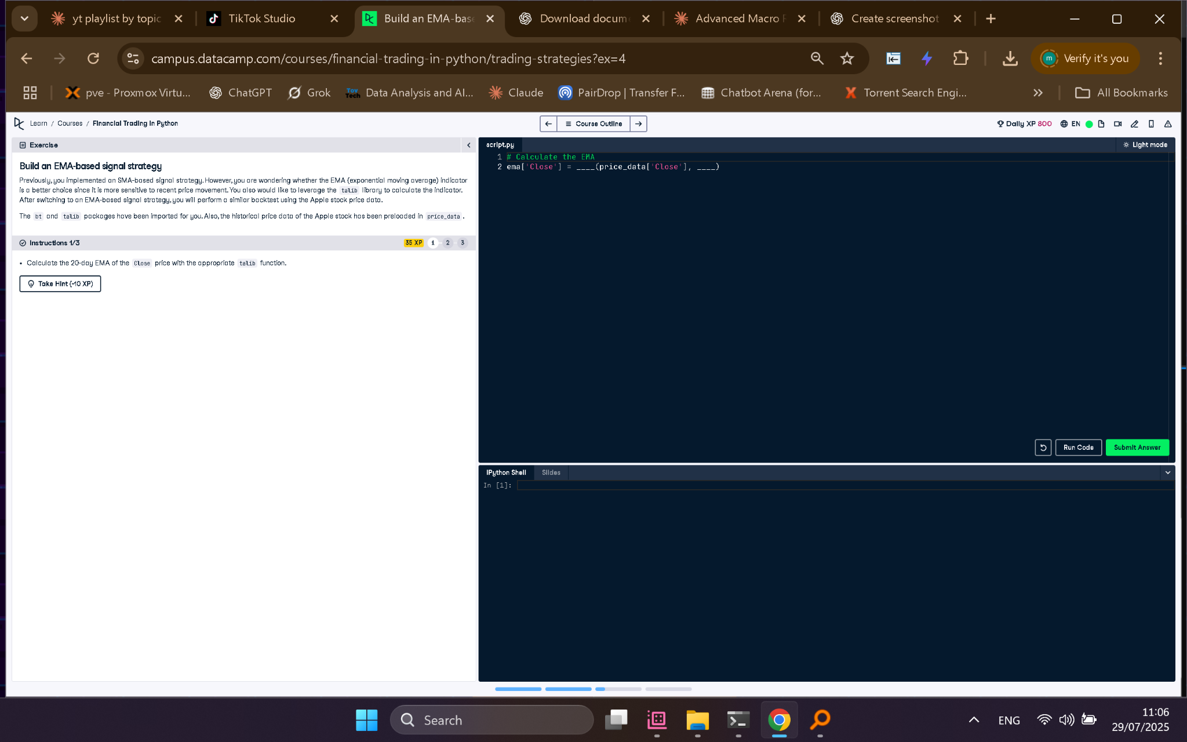

## ✅ Full Python Code

# Calculate the EMA  
ema['Close'] = talib.EMA(price_data['Close'], timeperiod=20)

## 🧠 Explanation in Simple Words

The EMA (Exponential Moving Average) is calculated for the 'Close' prices over a 20-day period using the talib library. Unlike the SMA, the EMA gives more weight to recent prices, making it more responsive to recent price changes. This can improve trading signal timing.